From: <https://grantpiperwriting.medium.com/what-happened-when-the-us-detonated-a-nuke-in-outer-space-553f2dc01b67>

Author: Grant Piper, a 4 min read

# What Happened When The US Detonated a Nuke In Outer Space?

## **The first large-scale EMP test**

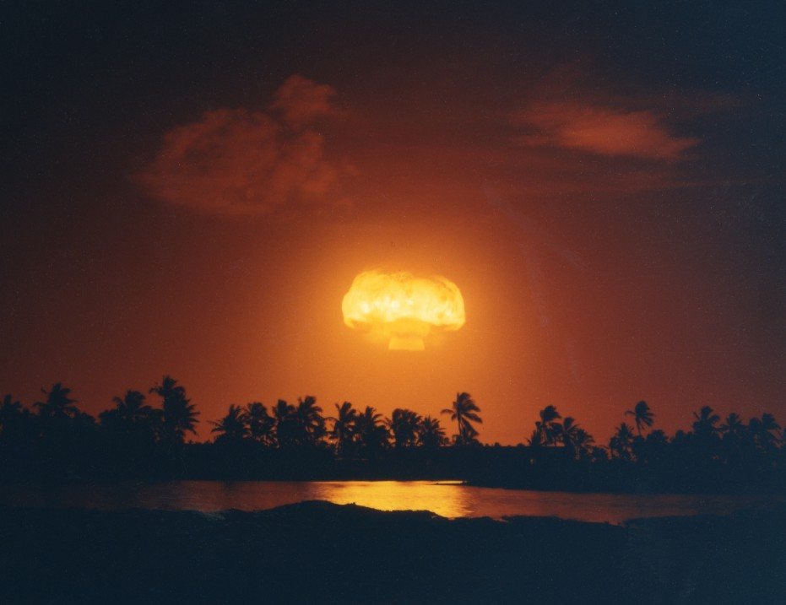

(Energy.gov / Public domain)

The world has recently been [buzzing about the prospects of an EMP attack](https://grantpiperwriting.medium.com/are-emp-balloons-the-future-of-warfare-3c4e0cd41c14) [<- Click here for more than what's below. (Are EMP Balloons The Future Of Warfare? (A 4 min read; 10 min with comments.))] in the next major war. Powerful electromagnetic pulses, or EMPs, can be generated by detonating a high altitude nuclear weapon. The effects of such an attack have been the subject of much speculation and debate in recent years between military planners and scientists.

Most people are speculating about the effects of an EMP based on conjecture. However, the United States once detonated a massive nuclear weapon in outer space to study its effects. The explosion resulted in the first true EMP energy blast in history. It is one of the only glimpses we have of an actual high altitude EMP blast.

The test was called Starfish Prime, and it was conducted in 1962. The results surprised nearby naval observers.

Here is what happened.

**The Test**

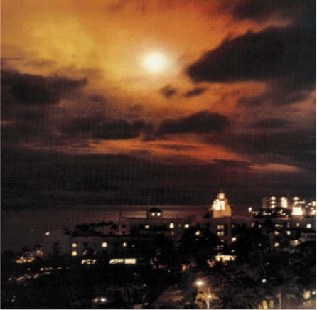

The glow as seen in Hawai’i (Public domain)

On July 9th, 1962, a massive Thor missile was launched from Johnston Atoll. The missile was carrying a W49 nuclear warhead. The warhead was rigged to blow with a yield of 1.4 megatons. Nearby ships watched the rocket streak upwards, and upwards, and upwards. Starfish Prime was a high altitude nuclear test designed to gather more information about nuclear weapons’ effects on the atmosphere.

The nuke eventually exploded at an altitude of 250 miles above the Earth. Observers pointed all of their recording instruments at the explosion, hoping to gather as much information as possible. But the instruments were going haywire. The scientists had underestimated the strength of the EMP blast that came careening down from the heavens.

**A Real EMP Bomb**

The bomb was detonated high above the Earth and 900 miles from Hawai’i. But that didn’t stop the powerful waves from reaching the island. The EMP blast swept across Hawai’i, knocking out streetlights, telephones, alarm systems, and microwave emitters. The government was shocked. They couldn’t hide their nuclear test as it had affected so many people on the islands. A faint glow could also be seen over the horizon.

The EMP also scrambled the instruments meant to gather data about the blast. A series of small rockets were launched to gather data, but the results were not what they had hoped. Much of the data was off the charts and could not be properly parsed through the interference.

The blast also knocked out three US satellites that were flying nearby in orbit, showing the scope of the EMP explosion. This was also unexpected.

The nuke left a scar in the sky. A strange aurora lit up the waters of the Pacific Ocean as charged particles reacted with the atmosphere like the Northern Lights. However, these lights were tropical and were created directly by human hands.

**Conclusion**

The results of the Starfish Prime test were surprising and unsettling. The force of the blast was much stronger than people first thought. The charged particles hung around in the atmosphere in a radiation belt for years after the fact when scientists thought they would dissipate in mere days. The explosion affected Hawai’i even though it was 900 miles away and 250 miles over the surface of the Earth. The results raised a lot of eyebrows and made many people realize that we might not understand nuclear weapons as well as we think we do.

Perhaps because of these surprising results, high altitude nuclear testing ceased in 1962, shortly after Starfish Prime. **The USSR detonated its last high altitude nuke in November, just days before the United States detonated its last one.** Watching a haunting aurora spread out over the Pacific showed everyone that they were messing with something that was best kept under wraps. No more high altitude nuclear explosions.